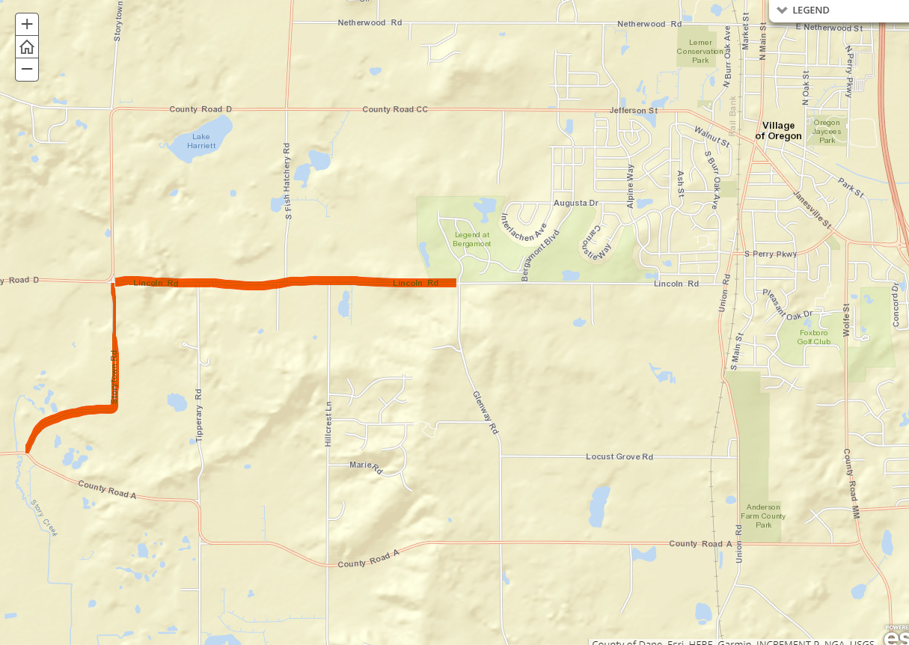

**Closed for repaving;**

**Lincoln Rd. & Storytown Rd.**